Ada Buggy Project

by Jerry Petrey

This paper describes my Ada Make project in detail so that anyone could reproduce it.

This project is built using the MikroElektronika Buggy vehicle (about $200). The controller board is a STM32F407 based MikroElektronika Clicker 2 board and all the control software is written in GNAT Ada using the 2016 Windows GNAT for ARM release. It has four custom click boards make by me with the following components:

1. A 128x128 OLED Adafruit display board.

2. A buzzer board with a piezo buzzer for music and sound effects.

3. A Sharp IR sensor board using a GP2Y0D810Z0F sensor for close range (10 cm) object detection.

4. A board with a servo mounted LIDAR-Lite sensor from Pulsed Light, Inc. for longer range object detection.

I have written Ada drivers for all of these boards and components.

I have all the source code in a single directory which includes the latest AdaCore Ada Drivers Library files along with my custom drivers and some modifications to the AdaCore files. I place the project folder on my computer at C:\Projects\GNAT2016\Demo_Buggy_Clicker2 and in that folder I have the obj and src directories as well as the Demo_Buggy_Clicker2.gpr file. There is also a bat file to quickly convert the executable to a hex file for loading into the Clicker 2 board via the ST_Link utility and the ST_Link/V2 hardware debugging and programming pod. This arrangement makes for a nice development environment because under GPS this gives a single project src folder for easy access to all the source code files. You can make your changes to a file, do a Build_All under Projects\Build and the executable is created in the project folder. The ‘create hex.bat’ file quickly converts this to a demo.hex file which can then be loaded into the Buggy controller board via the ST-Link/V2. Since I work with quite a large number of ST boards, I find having all the files in one src directory for each board is useful (especially during development) since sometimes it is necessary to modify certain AdaCore files for a specific environment during development. I had a lot of the support of ST boards already written when the AdaCore drivers became publicly available so sometimes I use their drivers, sometimes mine or various combinations of both.

My overall reason for creating the Ada Buggy was not so much to produce a fantastic autonomous vehicle but to show what can be done with Ada and the ARM processors and put together a few drivers for various sensors to give a starting point for future development and improvements.

Below is a picture of the basic Buggy:

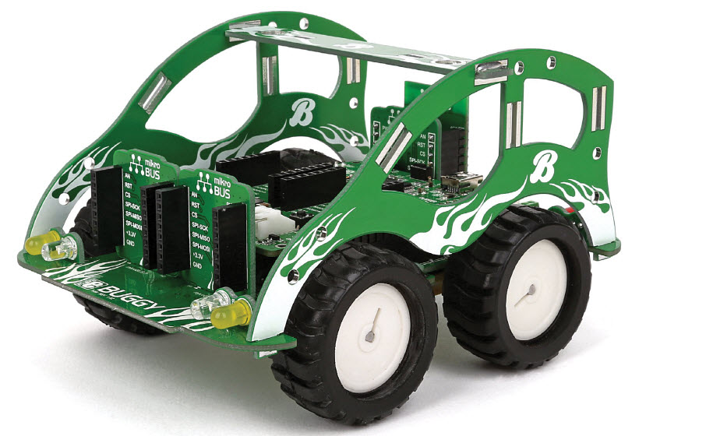

Here are some pictures of my version with my add-on Click prototyping boards:

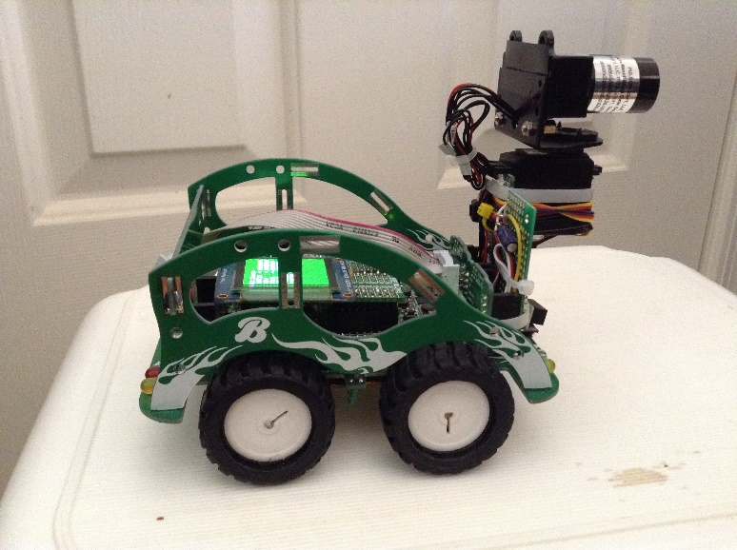 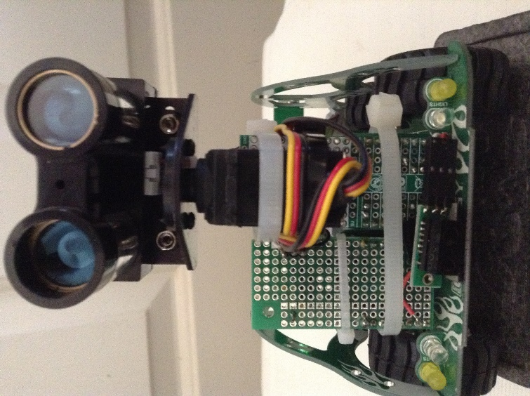

Photo 1 Photo 2

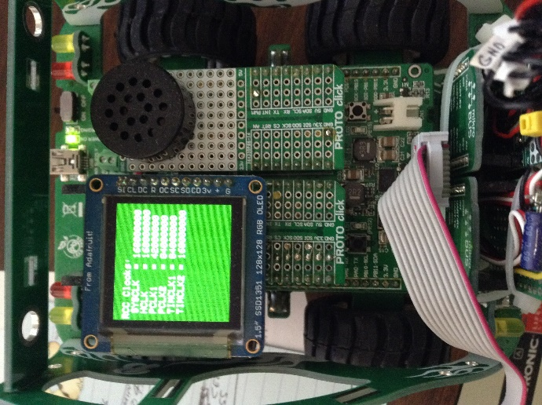 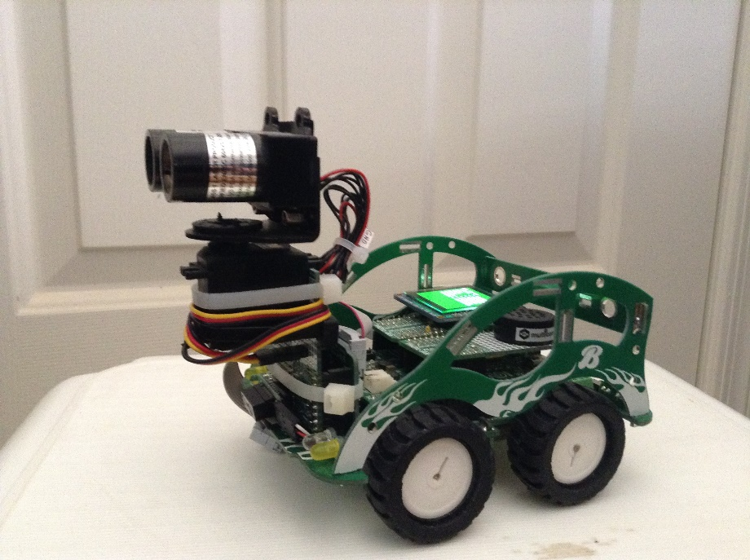

Photo 3 Photo 4

Note in Photo 2, at the very bottom is a small carrier board holding the Sharp IR sensor and above it the servo mounted LIDAR Lite board. The Click Proto board on the left just has the wiring from the Sharp IR sensor to the mikro BUS (MikroElektronika’s name for their standard interface bus) slot on the Buggy. In Photo 3 (a top down view), you see the OLED display board and the piezo buzzer board as well as the ST-Link cable for downloading programs to the Clicker 2 board. The Buggy has LEDs for turn signals, stop lights, and high and low beam headlights, all of which are controlled by my application during respective driving states.

After you unzip the project zip file to your desired location, you also need to place the runtime folder (ravenscar-sfp-stm32f407hse25) in the GNAT ARM runtime location (typically: C:\GNAT\2016\arm-eabi\lib\gnat ). My runtime is essentially the same as AdaCore’s for the F407 Discovery Board except it is built for a 25 MHz HSE crystal frequency as used on the Clicker 2 board. Double clicking on the gpr file should bring up GPS and you are ready to go. MikroElektronika has dozens of Click boards for this product line but I just used their blank prototyping boards to build up the sensors and add-ons I needed. This is a very versatile system!

Below are details of the OLED LCD and LIDAR and Servo wiring to their respective mikroBUS Prototype boards that I created and installed on the Ada Buggy.

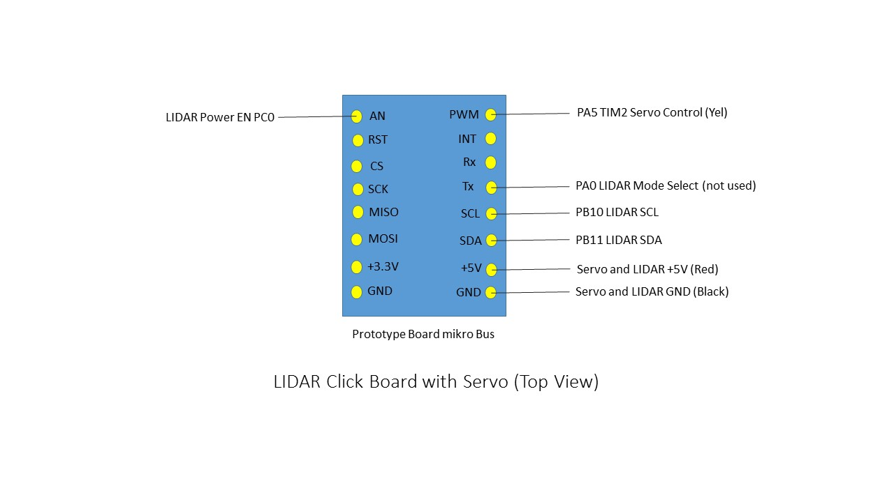

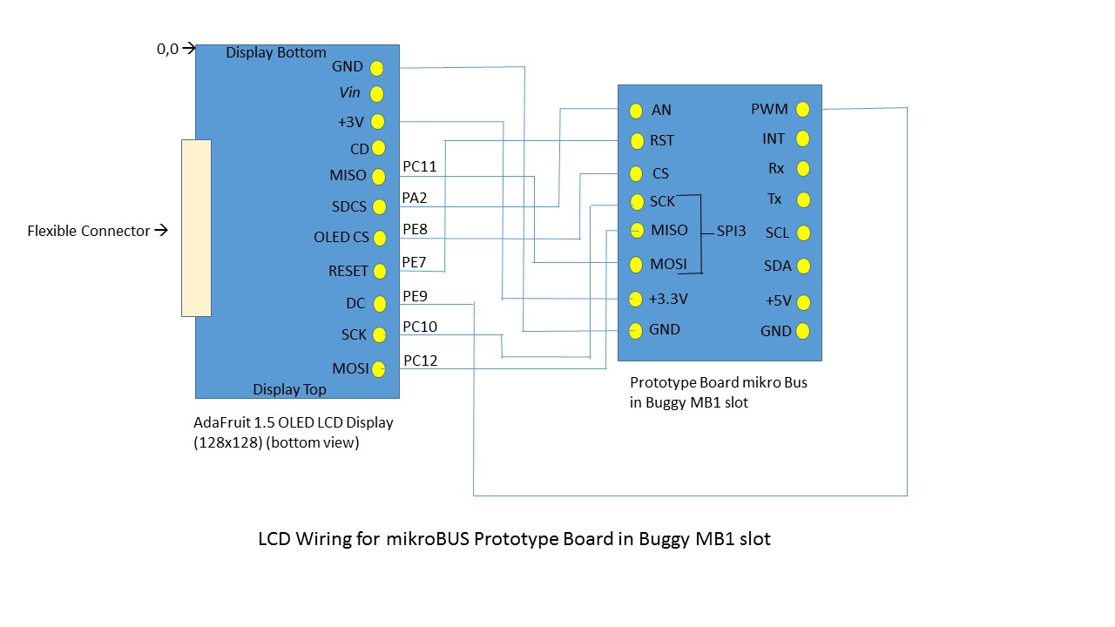

Note that the LIDAT Lite (version 1) that I used is no longer available. It was made by PulsedLight, Inc. which was bought by Garmin. This first version had some weird I2C issues that my I2C driver handled OK. They later made a LIDAR Lite V2 which had a better I2C interface but it is hard to find now also. They are just getting ready to start shipping a new LIDAR Lite V3 which has some new improvements (and at the same price) so it should work fine in an application like this.

The Sharp GP2Y0D810Z0F IR sensor is available from many sources on a small carrier board and is easy to use. You just need to detect when the sensor output pin goes low to tell when an object is within its range (10 cm in this case). For the mikroBUS slot I use on the Buggy this is wired to PC1. Likewise, the buzzer I use is a common large format piezo buzzer connected to a prototype board in mikroBUS slot 2 on the Clicker 2 CPU board and connected to PD12 and controlled by PWM using a slightly modified version of AdaCores’s PWM drivers. It can reproduce a range of frequencies and I have a simple musical note package to support it.

In September 2014, I had an article published in Electronic Design on my work with GNAT Ada support of the STM32F407 Discovery board which also used the same LIDAT Lite module. That article can be found here:

<http://electronicdesign.com/dev-tools/armed-and-ready>